Exercise: Scaling to 100 million customers

## Identify the weakest link

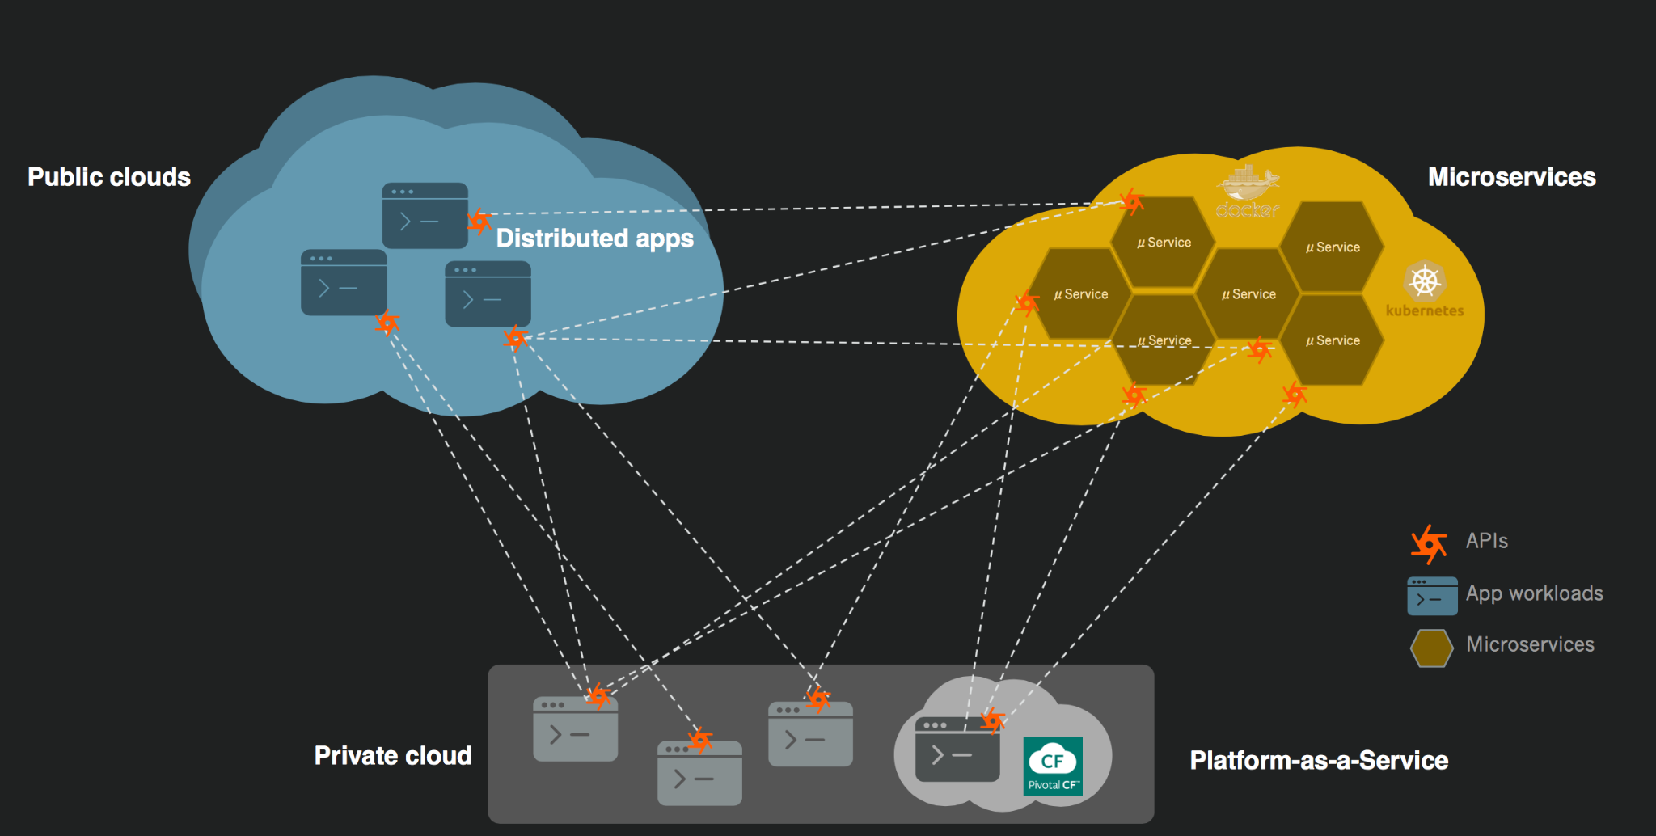

## Evaluate Global Rollout

